The Council for Exceptional Children, Division of Early Childhood’s position statement states:

“Inclusion as a value, supports the right of all children,
regardless of their diverse abilities, to participate actively
in natural settings within their communities.”

“Inclusion” is characterized by a feeling of belonging, not by mere proximity, on which the earlier term “mainstreaming” focused. Inclusion is children of all abilities learning, playing, and working together. With successful inclusion, all children are actively involved, physically accessing play and work locations, and have options from which they can choose personally. Inclusion is a process, not a placement. No one person is responsible to make it work; it takes group effort. There is not one perfect way. The inclusion process needs to be tailored to meet the needs of each child as well as the program.

Inclusion as it relates to the law
Privately operated centers or family child care homes must provide equal opportunity for children, parents, and others with special needs to participate in programs and services. There are exemptions from this law, however, based upon reasonable accommodation. “Best practice” for children and families allows for access to programs that could benefit the child.

Theoretical Basis for Inclusion
Lev Vygotsky, a Russian-born social scientist writing in the 1920s, provides the basis for a theoretical background for inclusion. He believed that people learn through socially interacting with others who are more “expert” in a given ability or field of knowledge. Thus, he concluded, the greatest difficulties for children with special needs are created not by their particular special needs, but by isolation from typically developing peers. Children with special needs should be in groups with same-age peers whenever possible.

Vygotsky believed that cognitive and language development is socially based, with children first learning new ideas on the social level with more-capable peers and adults, then incorporating those ideas on an internal or psychological level. Therefore, the most important aspect of an early childhood program for children with special needs is improving social skills and interaction with adults and more-capable peers. (taken from Berk, L.E. and Winsler, A. Scaffolding Children’s Learning: Vygotsky and Early Childhood Education. Washington, D.C., NAEYC.)
Why Promote Inclusion?
Children learn from each other. When they are exposed to inclusive environments starting at a young age, they learn acceptance of other people and that each person has unique abilities.

• make friends
• learn by imitating others
• show more pride in achievements

Benefits of inclusion for children with or without disabilities

• build interdependence and ability to deal with obstacles
• notice similarities between themselves and others
• develop better language and communications skills
• develop interpersonal skills
• increase problem-solving ability
• learn to become more assertive
• learn self-respect by being a part of a positive, natural
environment
• learn to accept others as they are
• develop patience and compassion
• learn to accept their own strengths and needs
• accept others as individuals, not “labels”
• learn to help others

• enable families to work because they have increased access to child care services

Benefits of inclusion for families

• understand that all children have negative behaviors such
as tantrums or toilet problems
• discover that others can provide a secure and nurturing
environment for the child with special needs
• learn to accept children’s strengths and needs.
• share common experiences
• feel a kinship with other families
- The opportunity to see chronologically age-appropriate activities

• develop networks of professional services and

Benefits of inclusion for early care and school age care education providers

community resources
• expand their knowledge about special needs
• develop awareness that all people have unique needs
• create a setting that encourages understanding
and flexibility
• realize and appreciate differences
• develop compassion, kindness and respect for others
• acquire a larger share of the market by enhancing their
own images
• Children who do not have special needs continue to learn
and grow the in same ways in which they did before they
had classmates with special needs. In addition, they

Benefits of inclusion for children who are developing typically and their families

have opportunities to learn about differences in human
growth and development. They learn to accept people
who are different from themselves as they learn to work
and play with children who have a wide range of
abilities.

• For families of children who are typically developing,
the inclusive setting provides a concrete opportunity for
teaching their children about differences in growth and
development. Families might develop a greater
understanding of people with special needs, become
more sensitive to the needs of families with children who
have disabilities, and become future advocates for
community integration.

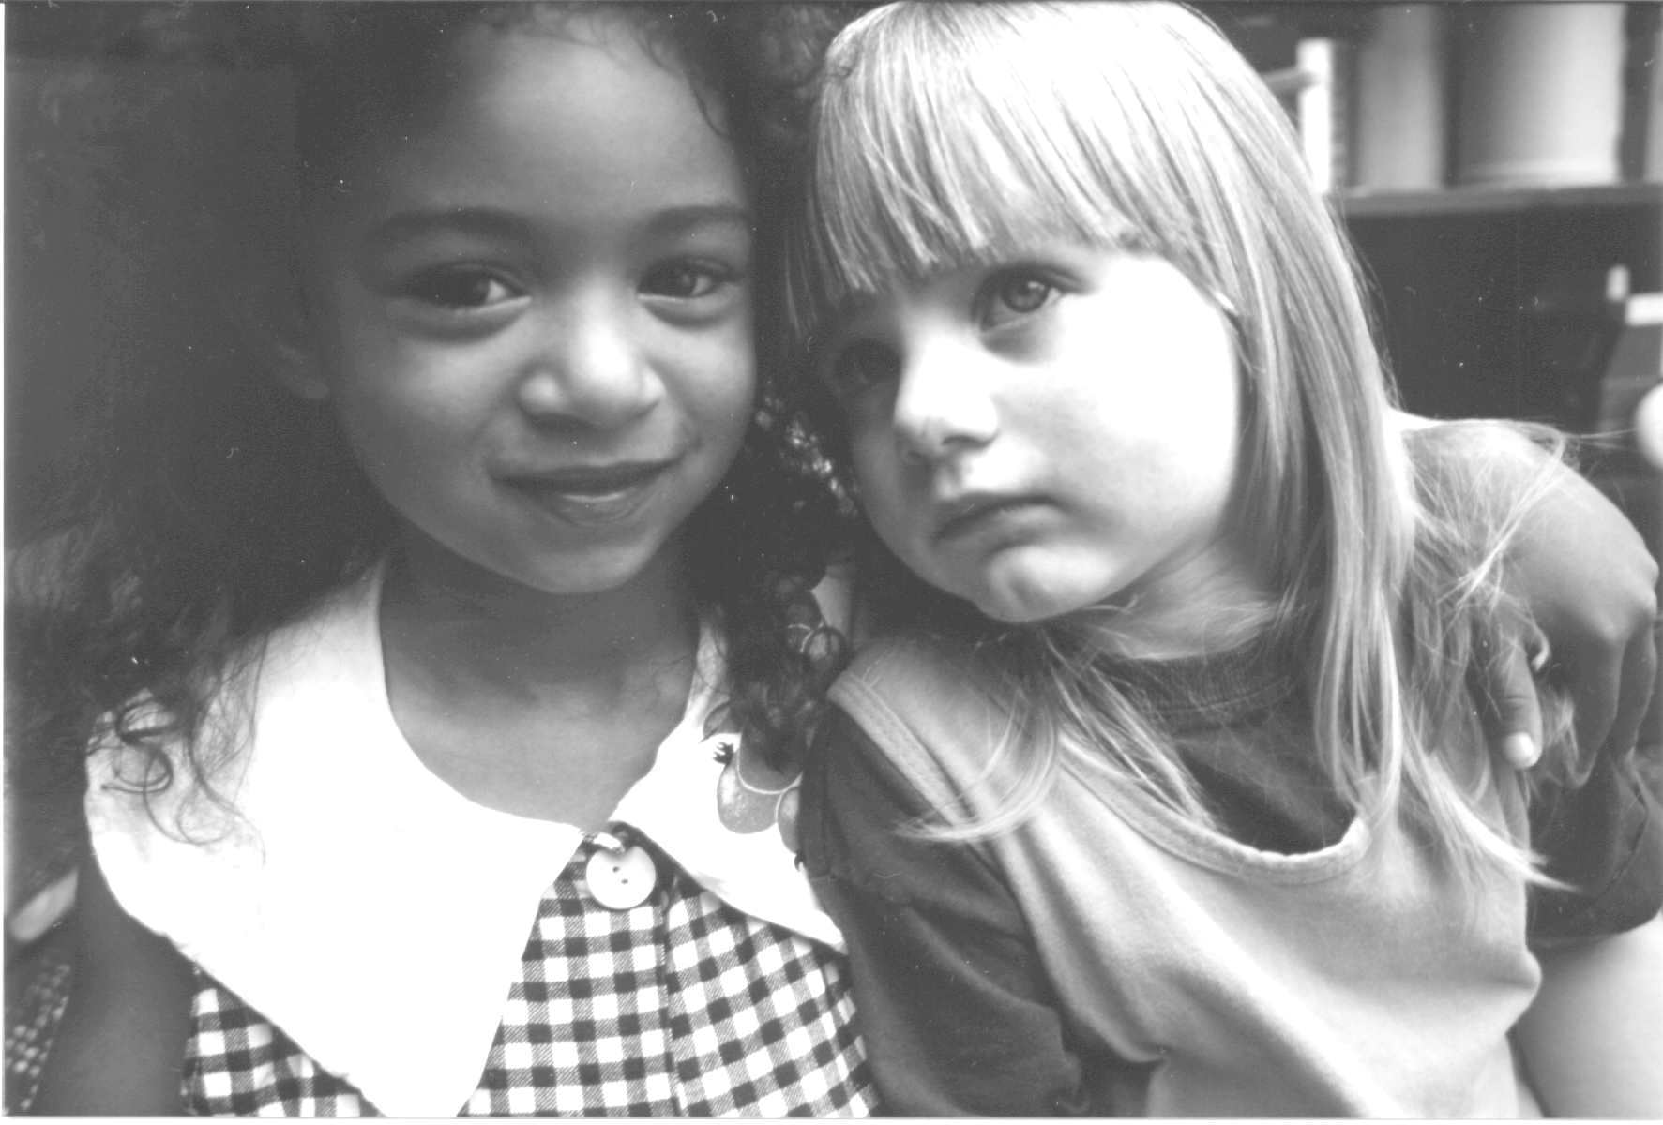

Excerpts of these lists taken from Quick Notes, Inclusion Resources for Early Childhood Professionals. University of North Carolina, 1997, FPG Child Development Center, Carrboro, NC.

